Screen:

Welcome page:

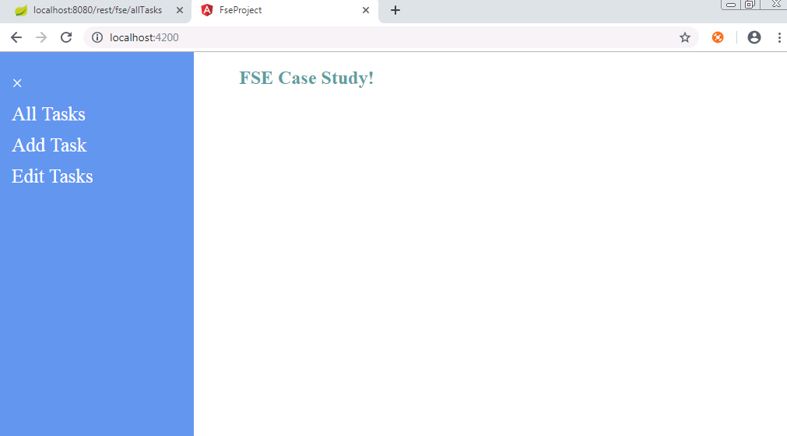

All Tasks- Tab will show all the existing tasks, here use can delete a task as well. Including status of every Task. Data is stored based on the priority.

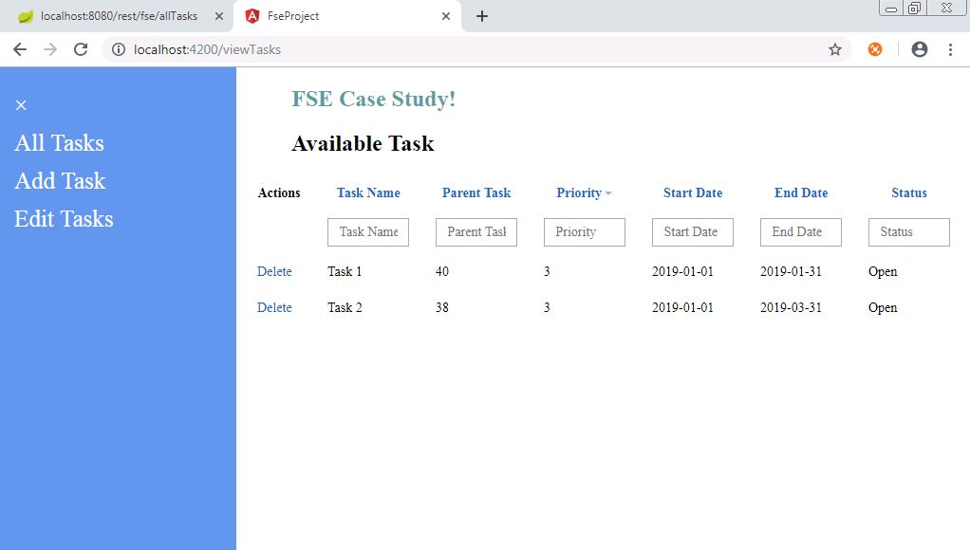

Add Task - User can add a task using this component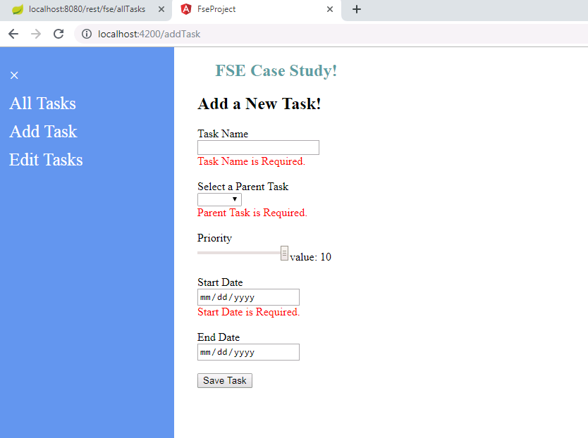

Adding a new Task 3, chose Task 2 as parent Task. Task Name, Parent Task and Start Date is madatory. 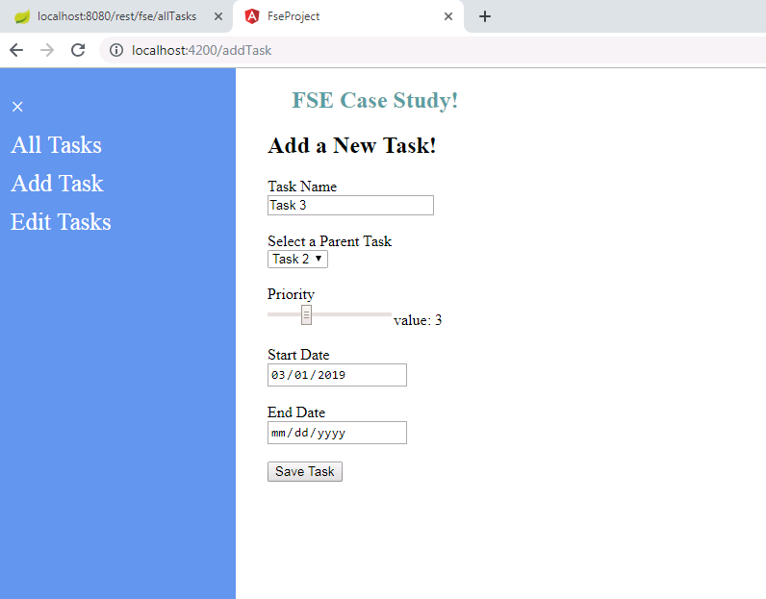

Save Task - Once Task is saved successfully. User will be navigated to All Task screen to see updates. By default the status is set to Open.

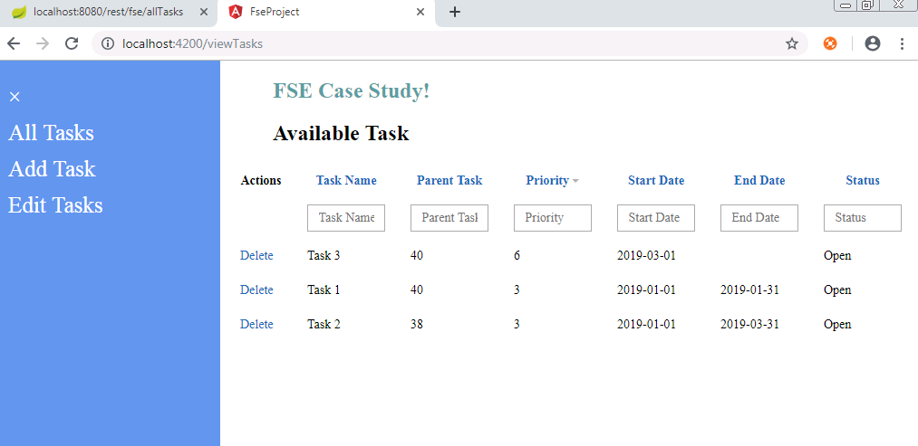

Edit Task Component - Use can select a Task and update the data accordingly. User can even mark the status as Open/Close.

